Design System

By: BioInvaders

# Sections:

1. Colors
2. Typography
3. Components
4. Spacing

Colors

For the colors, green, blue and purple tones have been used to represent space (and in our case, a touch reminiscent of biology). In the home screen we can see that the background is a gradient of these 3 colors.



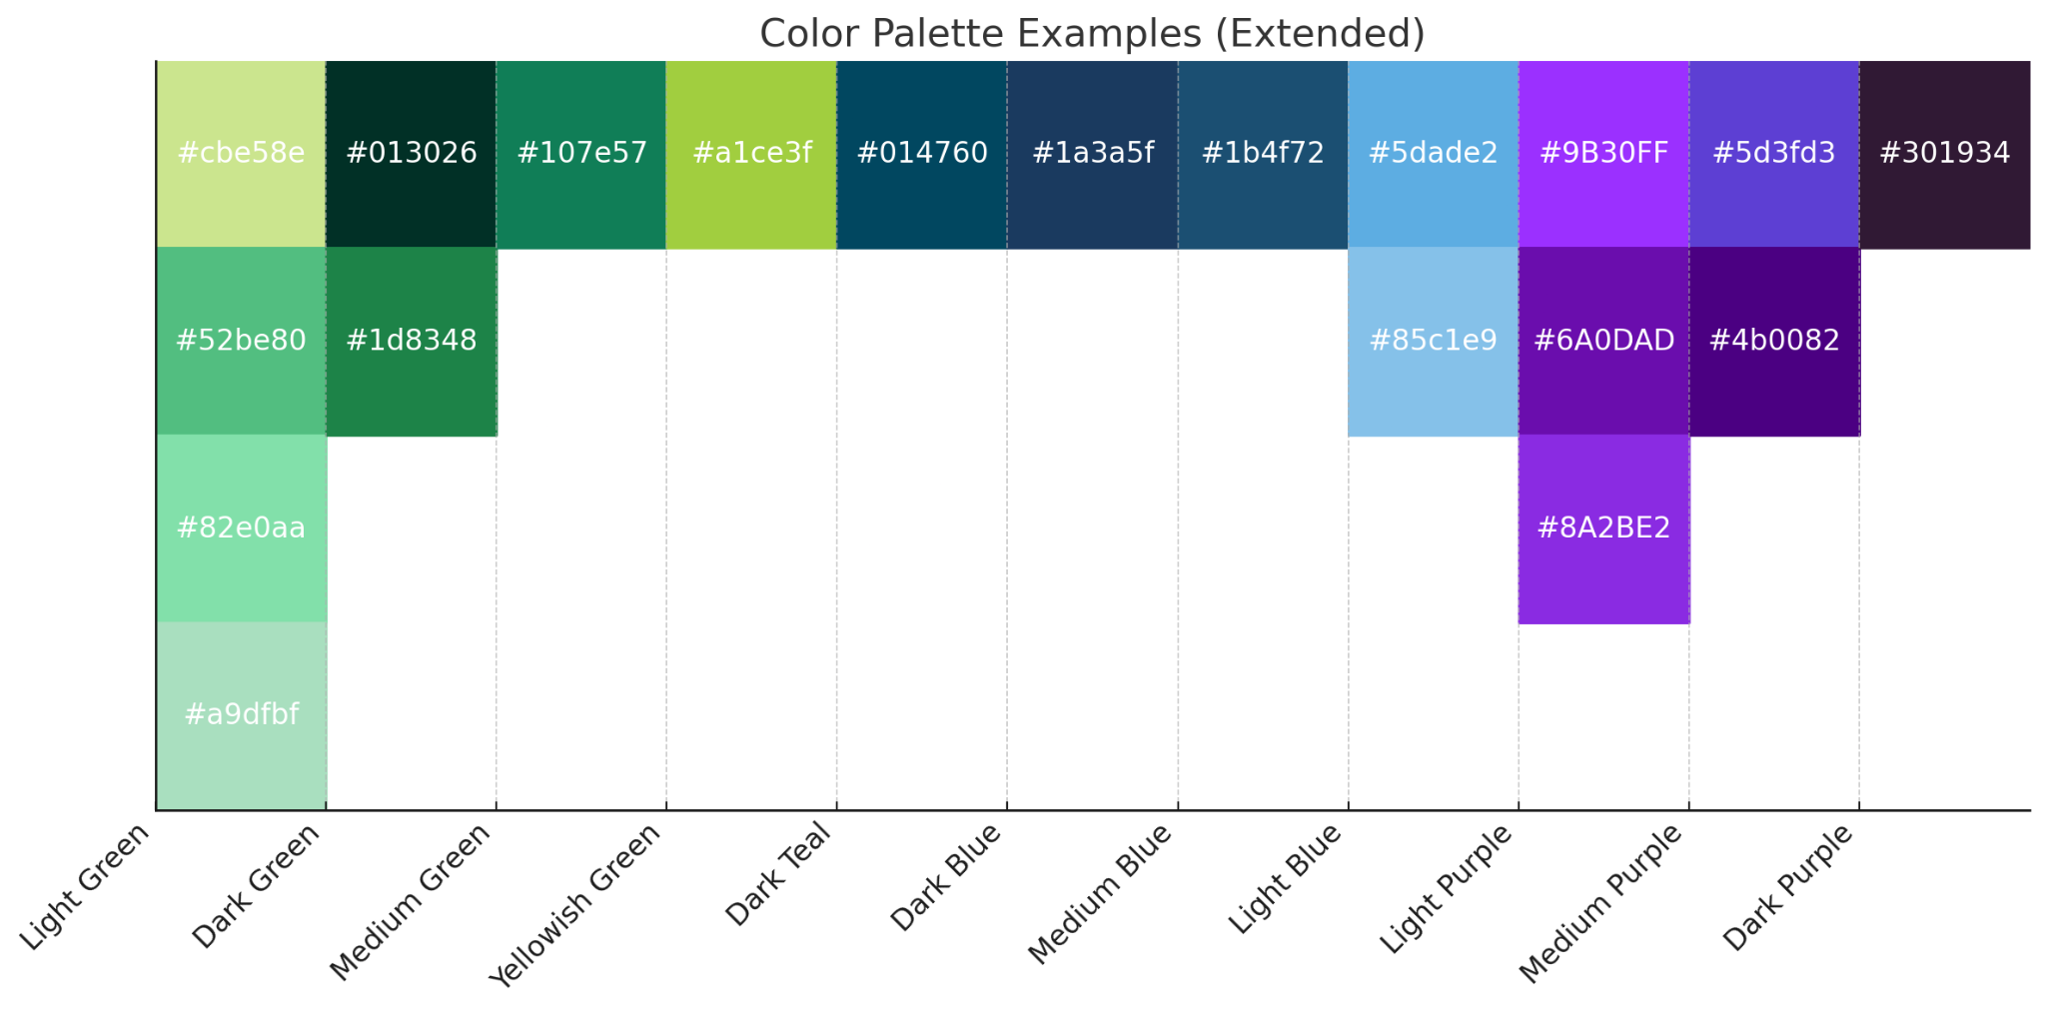

1. Green

* Light green:  
  #cbe58e

#52be80

#82e0aa   
 #a9dfbf

* Dark green:  
  #013026

#1d8348

* Medium green:  
   #107e57
* Yellowish green:  
   #a1ce3f
* :

1. Blue

* Dark Teal:  
   #014760
* Dark blue:  
   #1a3a5f
* Meidum blue:  
   #1b4f72
* Light blue:  
   #5dade2  
   #85c1e9

1. Purple:

* Light purple:

#9B30FF

#6A0DAD

#8A2BE2

* Medium purple:

#5d3fd3

#4b0082

* Dark purple:
* #301934

Typography

The texts are mainly white, of an intermediate size (removing important elements such as headers, buttons or decorations like the name of the team) and contrast with the background of darker colors.

1. Use of white color for text, bold highlighting in specific areas to draw attention or highlight important information.

(Team name)



(Copyright)

1. Use of underline for clickable elements



(Register button)

Components

The use of different components for a more dynamic and efficient handling.

Buttons (2 types):

1. Single button:

* Simple structure followed by all buttons in terms of margin, borders and rounding. It has a simple underline detail to indicate that it can be clicked.



1. Eye-catching buttons:

* These buttons have a more eye-catching design, with the idea of standing out more and attracting the user's attention.





Spacing

For spacing there is a very simple structure:

- The header has the elements on each side of the screen, left and right. It includes the name of the group and the login buttons.

-The main is mainly centered, accumulating all the information about the project in the center of the screen.

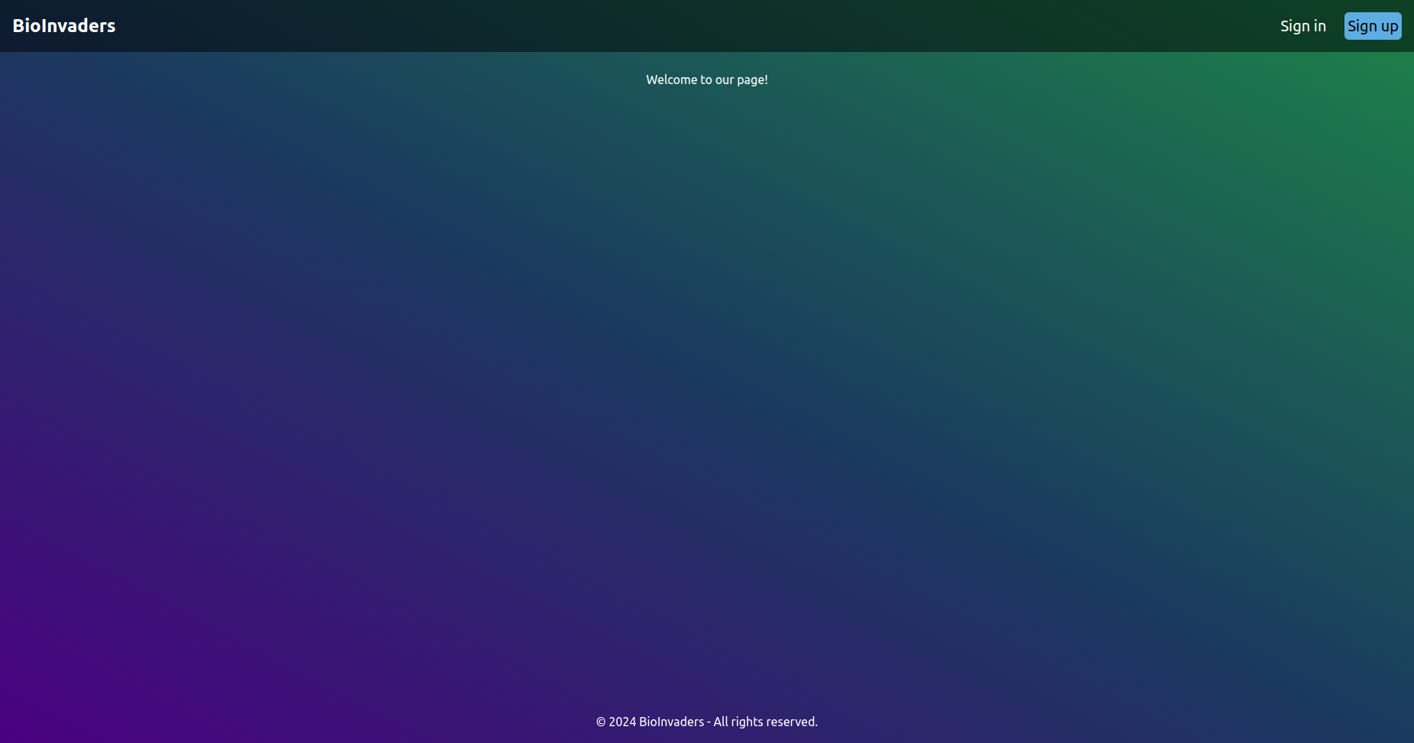

-Mainly the elements are separated with the use of justify-center (for the main information and footer) and justify-between (for the header).

